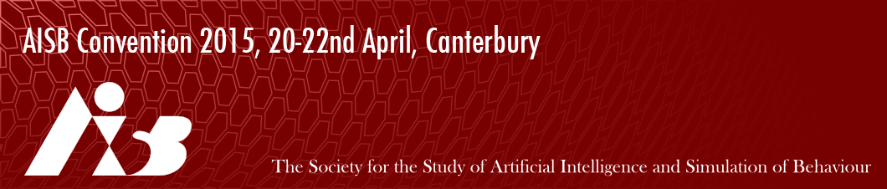
AISB Convention 2015 Proceedings Copyright Form
Paper Title:
Author(s):
The author of the manuscript identified above and any supplemental tables, illustrations or other information submitted therewith (the “Work”), to be included in the AISB proceedings, grants to the SSAISB a non-exclusive right to print, publish, reproduce, or distribute the Work throughout the world in all means of expression by any method known or hereafter developed, including electronic format, and to market or sell the Work or any part of it as it sees fit, for the full term of copyright and all extensions and renewals thereof. The author further grants to the SSAISB the right to use the author’s name in association with the work in published form and in advertising and promotional materials. Copyright of the work remains in the author’s name, and the author reserves all other rights.
The author agrees not to publish the work in print form prior to the AISB 2015 convention. The Author represents and warrants that the work:
(a) is the Author’s original work and that the Author has full power to enter into this Agreement;
(b) does not infringe the copyright or property of another;
(c) contains no material which is obscene, libellous, or defamatory.
The Author shall indemnify and hold the SSAISB harmless against loss of expenses arising from breach of any such warranties.
Signed:

Date:

