The LondonMet Challenge - “Green” Route Finder

We expect everyone who is here today will have used a form of public transport to get to the University. We are seriously concerned about the carbon footprint of mass transport systems.

We want you to design a program, which will simulate a route planner calculating the best route from A to B and outputting the total cost, time and carbon footprint. The system must provide a user with the best route, which prioritises speed (time taken), cost or environmental impact. This could be translated into a practical, real world transport planner and so should allow for easy manipulation of all the variables. The final part of the task is to allow the user to input time, cost and carbon footprint constraints in minutes, pounds and kilograms respectively. All the information should be shown including a map displaying coordinates or station names.

The map shows a sample route. The user can take either a train, bus or walk along each of the “roads” which will travel the same distance horizontally and vertically. There will be no diagonals. The different means of transport all have different speeds, prices and emit different Co2 levels with the train moving faster than the bus and emitting less CO2 but costing more.

The challenge is to find the “greenest”, cheapest or the fastest route from A to B within the set time limit and budget.

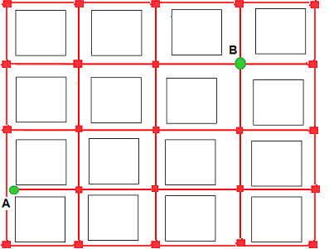
Tasks

- Create a 5 by 5 map, which displays names or co-ordinates in command line or a GUI. (10 points)
- Find the shortest path between two points, which are inputted by the user using the coordinates or names from the map. (20 points)
- Find the cost, time and carbon footprint for the route with a particular transport method.
(10 points)
- Create an algorithm, which calculates the fastest, cheapest or greenest route using a combination of transport means given time, money or carbon footprint limits provided by the user. (40 points)
- Create a GUI for the application including map animation showing route from point A to B (10 points)
- Allow manipulation of map size, modes of transport and relevant variables to ensure flexibility of the program (10 points)

Test Data

Train (between stops)
Cost = 1 pound
Time =1 minute
Carbon Footprint = 50 grams per person per stop

Bus (between stops)
Cost = 50p
Time = 5 minutes
Carbon Footprint = 100 grams per person per stop

Walk (between stops)
Cost = 0.01p
Time = 30 minutes
Carbon Footprint = 0.01 grams per person per stop

Marking Scheme

Task |  | Marks
Create viewable map | - Display a 5 by 5 map using GUI or DOS command line  - Map shows coordinates and/or place names | /5  /5
Route planner | - Can find shortest route between two points inputted by user  - Points can be found using names rather than coordinates | /15  /5
Impact of each method of transport | - Can work out the cost, time and price of each transport method | /10
Best route | - Create an algorithm which calculates best route using any combination of transport means being:  - Fastest  - Cheapest  - Greenest  - Repeat the algorithm to allow a user inputted constraint on:  - Time  - Cost  - Carbon Footprint | /10  /5  /5  /10  /5  /5
GUI | - Create a GUI for the program  - Create animation in map to show route from A to B | /5  /5
Flexibility | - Allow for easy manipulation of each transports price, time & footprint  - Allow for adding more stations and modes of transport | /5  /5
 |  | /100

