Visual Bracketing for Web search Result Visualization

Jonathan C. Roberts and Edward Suvanaphen
Computing Laboratory, University of Kent
j.c.roberts@kent.ac.uk, es45@kent.ac.uk

Abstract
This paper introduces a novel visual bracketing method that provides detail-in-context views where the inner part contains the Focus bracketed by the context information at a lower semantic level We demonstrate two designs for web search result visualization that obviate the need to frequently select the next button for viewing multiple search results.

Keywords: Focus+context, detail in context, greeking, bracketing, multiple views.

Introduction
Search engines are an important part of information gathering, and serve as road signs for the Internet; they point the users in the right direction enabling them to find specific sites or general information about a topic. Traditional search engines (e.g. Google, Yahoo and Excite) visualize the results in the form of a text-based list. The actual data contained within each returned list varies from search engine to search engine, but in general, the title of the page is returned, a short extract of some text from the page is included along with a URL link to the page.

However one problem with search engines is that they return too much information, this coupled with a traditional text representation means that there is not enough space on the screen to display all the results. The search engine may find 100 or 100,000 pages of information relevant to the query. Conventionally the result list is divided into smaller portions and returned 10, 50 or 100 at a time, but it is only feasible to view 5 to 10 results at any one time on the screen without scrolling which this forces the user to click on the next button, to view the next set of results

Some critics may argue that search engines are becoming more effective at finding the ‘correct’ answer. While this may be true, it is often more beneficial to allow the user to select and decipher what they believe to be a correct answer rather than displaying a reduced set of results. Certainly, from our experiences browsing a larger set of results is useful, because the users develop and change their understanding of what and how they are searching based on the returned results. Thus, we believe it is more prudent to visualize a large number of the results. That may be achieved through distortion or focus+context methods that will provide a hierarchical view of the data.

Our aim is to design a visualization that (1) utilizes Focus+Context techniques enabling the user to more effectively browse through the results and quickly drill down to relevant information, while gaining an understanding of the context of the selected information; (2) uses multiple views to provide different levels of detail and additional information; (3) to display the results in a way that would be innately familiar to traditional web users.

We achieve this, first by using a text representation ─ that will be familiar to the users ─ and second by a bracketing technique where lower ‘level of detail’ brackets the regular representation to provide the detail in context.

Data Gathering & Visualization
This research focuses on visualization techniques rather than the data gathering process. Thus, we use the Google API to provide the required data, which provides a convenient way to gather web search result data and integrate it with an application.

  - Search results

The Google API is well-written and simple to use. For example, the search term string can be submitted to Google using the API, and the results are subsequently returned in a list of elements each named GoogleSearchResultElement’s (SRE’s).

One SRE contains nine variables concerning one url that matches the keyword search. In this work we focus on four of the main variables (title, URL, paragraph of text and page size). We use a model-view-controller design-pattern in our implementation, and thus store each of the SRE’s in a list that can be visualized on demand.

Web searching provides a rich data source and there are many variables that may be gathered and displayed. Indeed, some search engines such as Google and Vivisimo offer additional information in the form of thumbnail images and Cluster based semantics, respectively. The multitude of variables may be grouped into four categories [2]:

- The search query itself, including number of keywords, operators used (e.g. Boolean inclusion/ exclusion)
- Information about the actual search results, the SRE information (e.g. rank, text snippets, results from different engines or different sessions).
- The content of the information (e.g. media types, content size, position of keywords on the page).
- The structure of the pages, including the quantity of internal or external links, the position and layout of the site or page.

The Google API currently has some restrictions for example it cannot be run in an applet and limits the number of queries per day to 1000. We refer the readers to the online documentation to find out more about the Google API [1]. Gathering additional information can be achieved by using bespoke search engines or additionally visiting each site (returned in the SRE) [2] although this is obviously much slower than using the native API.

  - Search Result Visualization

The information contained within an SRE is mostly textual, thus the developer either needs to display the information in textual forms or develops an appropriate abstract mapping. In this paper we focus on visualizing the textual information rather than graphically displaying the SRE information. Different techniques may be used that simplify the text, extract keywords and phrases, or exchange parts of the text directly into graphics; for example, systems such as SeeSoft [3] and WebTOC [4] replace some of the lines of text with colored lines.

Other researchers have investigated graphical representations of the search data such as Cugini’s [5] three-dimensional scatter-plot and McCrickards SQWID [6] visualization. Dots and colour pixels are also commonly used to represent individual SRE’s. For example Dotfire [7] represents digital library search results, Sparkler [8] uses colored dots and relevancy in a bull’s-eye formation, TileBars [9] maps the position of the keywords and xFind plots relevance to y-axis and document size to the x-axis [10]. Finally, Cugini [5] compares textual and graphical interfaces.

Bracketing Concept & Design
Detail-and-Context is known by several names such as poly-focal projection, fisheye view and distortion-orientated presentation [11]. These techniques allow the user to first focus on features or interesting parts of the visualization while viewing the surrounding context. Reducing the detail, or distorting and squashing the information may form the context view. Moreover, sometimes a semantic change accompanies the viewing: increasing or decreasing the detail in the view (such as used by ToolGlass [12]).

The idea of visual bracketing is inspired from bracketing in photography. When professional photographers take pictures they make an estimation of the correct light and speed levels, set up the camera with these parameter settings and take multiple pictures with parameterizations either side. In defining bracketing, we quote “[bracketing is a technique where the photographer] takes a series of images of the same scene at a variety of different exposures that bracket the metered exposure (or manual exposure)” [13].

In our case we achieve a visual bracketing effect by displaying different semantic information in the fore and after visualizations. The inner part contains the detail view while the bracketed visualizations contain the context information at a lower level of detail. For web search result visualization the inner part contains full information about a number of search results while the bracketed views contain less detailed information such as solely the url, this is shown visually in Figure 1(center). Indeed, further bracketed views may enfold the former, showing less detail still. Thus the information is depicted in different views using various levels of detail, Figure 1 (right).
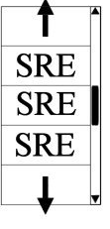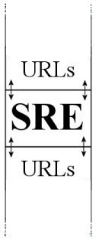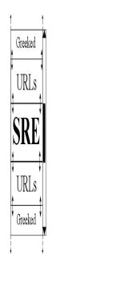

Figure 1. Schematics showing bracketed visual depictions of the Search Result Elements (SRE). Left, shows the traditional scroll list, each result in full detail. Center, shows the bracketed version with two levels of detail: full detail SRE that is bracketed by a simplified view of URLs. Right, shows a three-level bracketed view, with the third level being depicted by greeking.

The different level-of-details (LOD) may be generated from various algorithms, e.g. abstracting the information in some way or simply binning the information. In our implementation the second level depicts less information while greeked lines represent the third LOD. Greeking, as used by Robertson [14] as part of his document lens visualization and SeeSoft [3] in software visualization, exchanges the characters of the text by straight lines. This technique is useful to provide summary and overview information about a text document.

A sliding window methodology is also applied to the design, such that the user may directly slide the focus view up and down to change the information that is displayed in the center (and corresponding bracketed) views. This acts in a similar way to a fish-eye view [15], where the center window displays the full resolution and a lower level-of-detail is shown either side. But with our method there is a non-continuous change in the level of detail rather than a gradual change (along with a coincident semantic change).

Moreover, this visual bracketing concept is similar to the perspective wall design [16], albeit horizontal rather than vertical. The perspective wall technique displays the data in three dimensions on a two-dimensional wall. The user focuses on the information in the center wall, with the side parts of the walls to display the context; information on the wall may be scrolled to change the focus. The differences with our method are that (1) the bracketing may occur at multiple levels (brackets of brackets), (2) we employ a semantic level change and (3) the user may alter the brackets size.

  - Different interaction methodologies

User interaction needs to be considered when designing the visualization. In our design the user may decide on the width of each bracket, as depicted in Figure 2, as the bracket increases so the area (that it is moving towards) decreases the number shown.

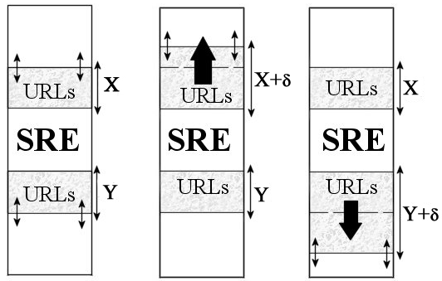
Figure 2. Schematic showing how the user can change the width of each bracket.

Additionally, the user may slide the focus window up and down. Although this seems a simple operation, there are different implementations; we describe two main variants of this operation.

First, the width of each window bracket is kept constant, apart from the outer most panes, as depicted in Figure 3. Thus, the user moves each of the brackets together as one unit: they are locked together. The information changes appropriately.

Second, the user may grab each inner bracket (the focus view) and move that up and down within the restriction of the width of the encapsulating bracket. If the user attempts to push past the boundary of the next bracket then that bracket width changes and moves as well, etc.

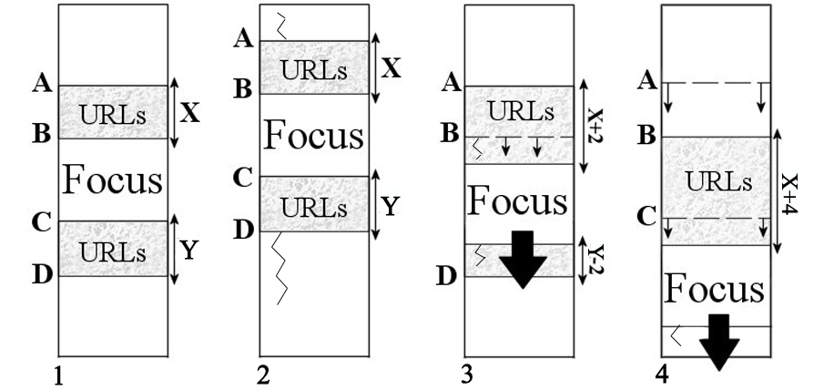

Figure 3. Schematic showing the different scrolling mechanisms. (1) The original bracketed view. (2) Constant width method where the surrounding brackets X,Y are kept constant and the areas above and below A,B respectively are enlarged/reduced. (2) and (3) show the inner-bracket scrolling method, where the panes may scroll inside the bracket up to the bracket end (3) or push past the bracket (4).

Realizations
We have implemented two visualization variants using the aforementioned bracketing model in order to compare and contrast the proposed concepts. The models have been implemented in Java 1.4 with Swing components. The first is based on our bracketing design (utilizing the first interaction methodology), and the second displays the information in multiple views (highlighting the information via a bracketing scheme).

  - Bracketing search result visualization

Figure 4 shows a screen shot of this realization. After the user types and submits a query to the Google web service a set of results are visualized according to our bracketing concept. One result is shown in full detail (focus view), the next n (in this case 5) are displayed either side as URL’s and the remaining results are displayed as greeked lines. The user can scroll up and down to alter the focus information, or merely click on any result (Greeked or URL) and the result will become the new focus view; the rest of the visualization rearranges itself accordingly. The user can view the associated web page by clicking on the link in the focus view, which opens the page in a new browser.

Users can bookmark results. These bookmarks are highlighted and allow the user to return to view these results at a later stage. When two or more results are bookmarked another scrollbar appears on the right-hand side (named the snap-bar). The snap-bar allows the user to move (snap) between highlighted results, enabling the user to quickly return to marked elements.

  - Multiple Views with highlighted brackets

The second visualization separates the semantic information into multiple views; a screen shot of this implementation is shown in Figure 5. Each view displays (in their own view pane) different semantic levels of the same SRE: full SRE information, URLs, greeked lines, respectively. Thus different multiform information is displayed in each view [17]. The pane containing the greeked list displays the entire list. The URL list displays ten results at a time, and the fully detailed pane displays five results at a time.

Each view is coordinated such that when the selected SRE changes in any of the views, the other views automatically update, keeping the views consistent. Again the user may bookmark elements. Bookmarking a result in one view will highlight it in all the other views.

The bracketing concept is simulated in this model by the use of coloured bands. This reinforces the context information between the views. Each colour band denotes the information that is visualized in the corresponding higher level of detail view. Thus, the highest detailed view depicts the current selected item, the next down highlights the elements that are displayed in the more detailed view along with the current selection, and so on. This allows users to match the currently viewed data elements in one viewing pane with those in the other view panes. This hierarchical association is used within the spiral calendar [18], where one view depicts the year, the next a month, then a day etc. The Highlighting colour is also different so that the user can easily distinguish which results that have been bookmarked.

Additionally, the length of the greeked lines visualizes the size of the document. This provides an additional layer of information and gives the user an additional visual cue to use when searching the list of results.

Evaluation
We performed a preliminary user trial with our implementations using 3 male and 3 female users, each user was given a brief demonstration of the program and then encouraged to interact with the visualization. Afterwards the user was asked to complete a questionnaire; the findings have been encouraging. Users found the controls of both models easy to understand and manipulate, users in general favored the second model stating that it made the search results easier to view and provided extra functionality compared to a normal search engine (e.g. Google).

When comparing the visualizations to Google and other search engines, the bookmark function was praised most as a useful tool to identify and remember SRE’s of interest. Users also agreed that the Greeked visualization provided a useful overview of the data (through the size representations in the Greeked lines) and that it aided them in their search by providing additional visual landmarks.

The models are currently undergoing a longer trial, comparing and contrasting our two display techniques with traditional text-based realizations. In this project we support early testing (early in the design cycle) because such user evaluations influenced our designs. For instance, initially we did not include size information in the greeked pane until after an early user evaluation. We are also investigating other user suggestions such as incorporating hot-keys (e.g. bookmark, move-to next bookmark, etc), and adding an extra view pane to display very large (10,000 or more) results more effectively (perhaps using pixel based techniques).

6. Future Work

The next challenge is to integrate these techniques closer with the browser such as integrating the navigation into a Web-Browser Toolbar. Indeed, we have already explored the use of Java Applets to incorporate the program into an HTML browser, but Applet security and the restrictions of the Google API have so far inhibited this development. Currently we are examining the use of Java Servlets to provide our web interface. Servlets can dynamically create HTML pages and hence can pass data to an Applet (through the use of <PARAM> tags) without faulting Applet security. Retrieving data from the Applet is also a problem because the Servlet can only pass data to the Applet. Using other search engines in place of the Google API may provide different data and hence create a variety of visualizations.

Figure 4. Screen shot of the bracketing visualization. The focus view shows the full detail of the Search Result Element, solely the urls are depicted in the adjacent bracket, finally greeked text (of the urls) are shown in the outer most level.
Figure 5. Screen shot of the multiple view variant. Separate semantic information is shown in each views: greeked lines, URLs, full SRE information, respectively. Different shades show the bracket information.
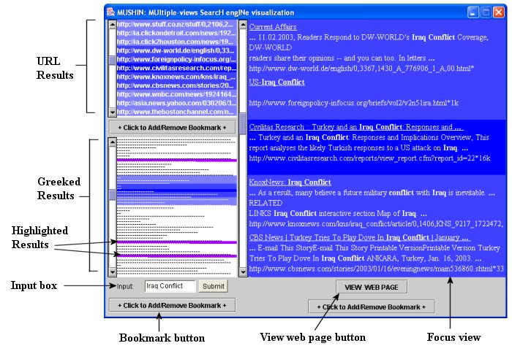
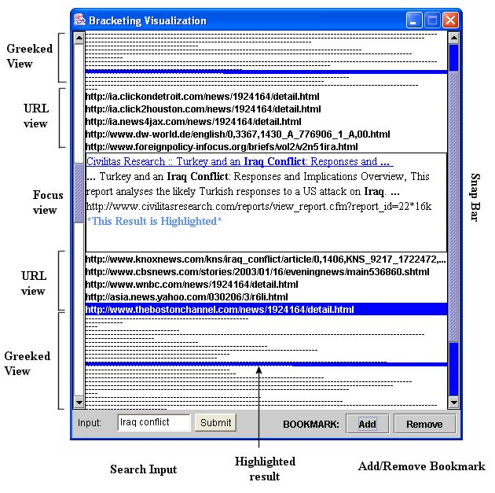

7. Conclusions
We have developed and implemented two designs based on the bracketing concept that successfully visualize web search results using the Google API. The ideas utilize detail-in-context and multiple view techniques to display search result data. From our user trial we discovered that overall users found the Bracketing visualization an improvement over normal search result visualizations because it is faster to browse results and extra features such as the result highlighting allow user to keep track of interesting results.

Finally, we believe the bracketing idea may be applied and adapted to many other applications and situations, and particularly useful for viewing of large data-sets

Acknowledgements
We thank the number of volunteers who evaluated our system and acknowledge Keith Franklin and Christian Jacobsen for their invaluable coding tips.

References:
- Google Web API url: http;//www.google.com/apis/
- Jonathan Roberts, Nadia Boukhelifa and Peter Rodgers. “Multiform Glyph Based Search Result Visualization”. In Proceeding Information Visualization 2002. IVS, IEEE, July 2002, pp. 549-554.
- S. Eick. “Graphically displaying text. Journal of Computational and Graphical Statistics”. June 1994. 3(2):127--142
- Ben Shneiderman, David Feldman, and Anne Rose. “WebTOC: A Tool to Visualize and Quantify Web Sites using a Hierarchical Table of Contents”. Technical Report CS-TR-3992. February 1999
- John Cugini, Sharon Laskowski, Marc Sebrechts, Joanna Vasilakis, Michael S. Miller. “Visualization of Search Results: A Comparative Evaluation of Text, 2D, and 3D Interfaces”. Research and Development in Information Retrieval. 1999, pp. 3-10.
- D. Scott McCrickard, Colleen M. Kehoe “Visualizing search results using SQWID”. In Proceedings of the Sixth International World Wide Web Conference. April 1997.
- Ben Shneiderman, David Feldman, Anne Rose, and Xavier Ferré Grau. “Visualizing Digital Library Search Results with Categorical and Hierarchical Axes”. HCIL Technical Report No. 99-03. June 1993.
- K. Perrine S. Havre, E. Hetzler and E. Battelle. “Interactive Visualization of Multiple Query Results”. In Proceedings of the IEEE Symposium on Information Visualization 2001 INFOVIS'01. 2001. pp. 105-112.
- Marti A. Hearst. “TileBars: Visualization of Term Distribution in Full Text Information Access”. Proceedings of CHI’95. May 1995.
- K. Andrews, C. Gütl, J. Moser, V. Sabol, W. Lackner. “Search Result Visualization in xFind”. In Proceedings UIDIS. IEEE Computer Society, 2001. pp. 50-58
- Y. K. Leung and M. D. Apperley. “A review and taxonomy of distortion-oriented presentation techniques.” ACM Transactions on Computer-Human Interaction. 1994. 1(2):126—160.
- Eric A. Bier and Maureen C. Stone and Ken Pier and William Buxton and Tony D. DeRose. “Toolglass and Magic Lenses: The See-Through Interface”. SIGGRAPH: Computer Graphics, Volume 27. 1993. pp. 73-80.
- url: Auto-Bracketing: http://www.dpreview.com/learn/
Glossary/Exposure/Auto_Bracketing_01.htm.
- G. G. Robertson, J. D. Mackinlay. “The document lens”. In UIST '93. ACM Press, Atlanta GA, USA, Nov. 1993.
- G.W. Furnas. “Generalized Fish-eye view”. In Proceedings of the SIGCHI conference on Human factors in computing systems. Boston, Massachusetts, United States, 1986, pp. 16-23.
- Jock D. Mackinlay, George G. Robertson, Stuart K. Card. “The perspective wall: detail and context smoothly integrated”. Proceedings of the SIGCHI conference on Human factors in computing systems: Reaching through technology. New Orleans, Louisiana, United States, 1991.
- J. C. Roberts. “Multiple-View and Multiform Visualization”. In Visual Data Exploration and Analysis VII, Proceedings of SPIE, 3960. January 2000, pp. 176-185
- J. D. Mackinlay, G. G. Robertson and R. DeLine. “Developing Calendar Visualizers for the Information Visualizer”. In Proceedings of UIST'94, ACM Symposium on User Interface Software and Technology. 1994, pp. 109-118.

