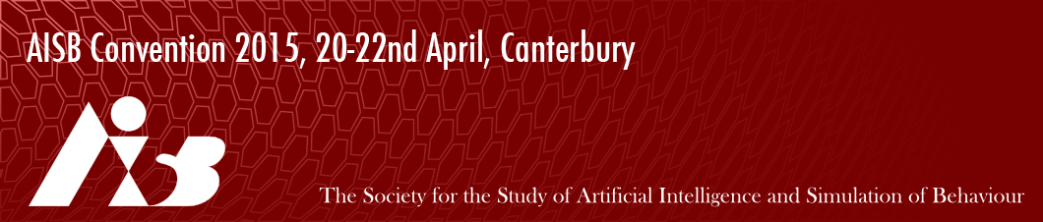

Student/Low-income Bursary Application AISB 2015
This form is for people who want to apply for a bursary to reduce the registration cost for the AISB Convention 2015. A limited number of bursaries will be available, in the form of a £75 reduction in registration costs. Students are eligible to apply for a bursary. We will also consider applications for people who are on low incomes, by which we mean people earning at or under the basic living wage, people whose sole source of income is unemployment /carer benefits, etc.
Please fill out the form below and return it to C.G.Johnson@kent.ac.uk. We aim to email you back within a week with our decision. Priority will go to people who are presenting at one of the symposia. If you are successful we will email you with a link enabling you to register at a reduced cost. The decision of the conference organisers is final.
Name:
Address:
Email address:
I am a student: Y/N
I am on a low-income (if Y please provide details): Y/N
Brief (one-two paragraph) description of why you think you should get a bursary:

