Advanced & Distributed Databases Home Page
The series of three screens below shows the main home page of the unit in the moodle-based “myCourse” VLE.
It starts with a header block of key resources, followed by each of the 5 theme blocks in chronological order including data mining as the last theme block. It concludes with the advanced topic block and end-of-course assessment hand-in and other information.
This theme approach, with 4-weeks for each theme, is designed to provide a flexible approach.
The following three screen shots show top, middle and bottom sections of the main home page.
Top

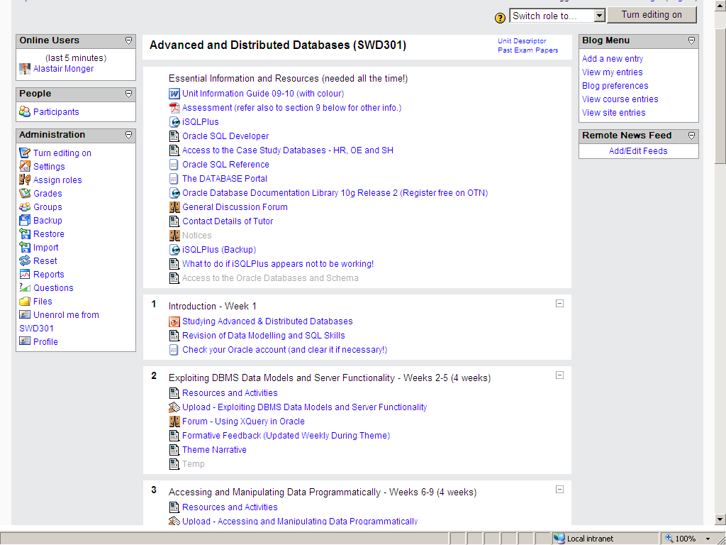

Middle
Each theme block has a similar structure to facilitate finding resources. In particular, each block starts with “Resources and Activities” link, followed by an “Upload” link (for a draft version of the assessment for formative feedback) and the forum for the advanced topic of the theme.

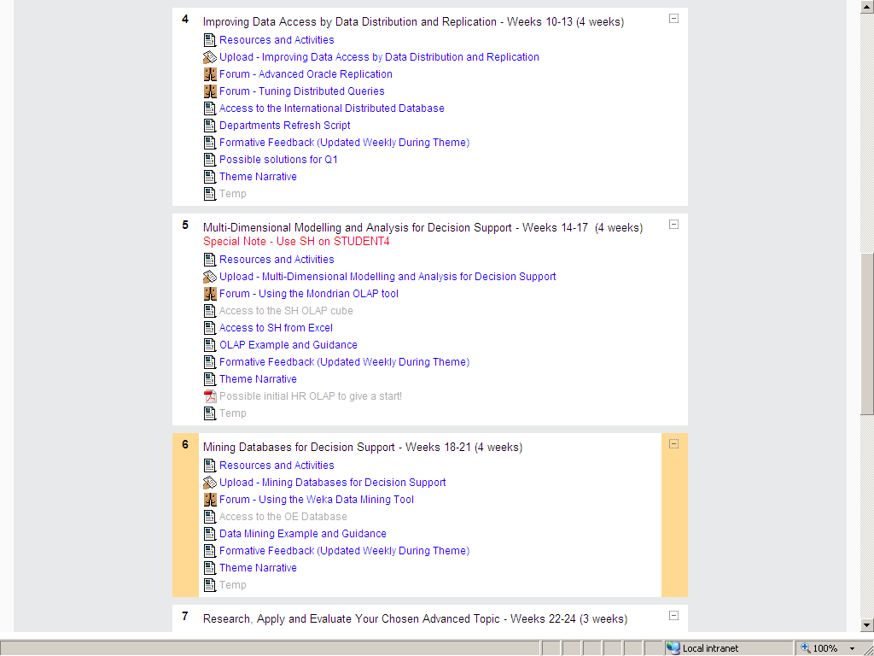

Bottom

