This tutorial will consolidate what you know or what you think you know about relational modelling from the first lectorial. We encourage you to work in groups on this tutorial to get the maximum benefit from sharing your knowledge with others.

Exercise 1
Remember the invoice exercise from the lectorial? Well here it is revisited to make sure we all have understood it.

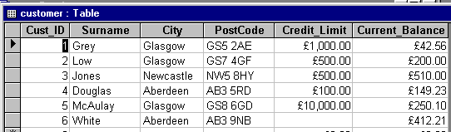
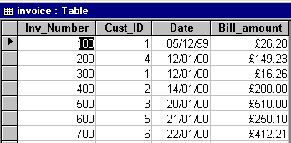
You should have come up with something like the model below. Make sure you have revised and understood a) all primary and foreign keys and b) that you have identified all appropriate relationships for the model
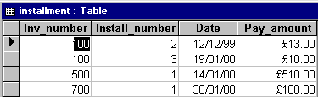

Exercise 2
We looked at anomalies in the lectorial. Let’s revisit this with another example here now.

StaffID | Name | Dept | DeptName | Phone
1 | Smith | 100 | Finance | 921
2 | Brown | 200 | HR | 888
3 | Grey | 300 | Marketing | 676

1) If you INSERT staff number 4 (Black) into department 100. What happens that you don’t like?
2) If you DELETE staff number 2 (Brown). What happens that you don’t like?
3) If you MODIFY the telephone number for Finance (remember you added another staff member earlier). What happens that you don’t like?

Exercise 3
Look at the scenario below for a flights database. It has been built WITHOUT any keys and therefore the integrity of the data may be in question as a result. So, in your groups or individually……………..

- Highlight the primary and foreign keys you would implement for this database. Justify your choices.
- Given you have now implemented your keys, highlight ALL violations of database integrity (i.e. entity and referential). Also, look carefully at other entries that you think should NOT be allowed.
- List examples of where nulls could be allowed and where they would cause violation

FLIGHT AIRPORT
Num | Date | Company | Airport | Terminal
485 | 25/7/02 | BM | Gatwick | 1
723 | 11/7/02 | BA | Gatwick | 1
889 | 41/7/02 | BA | Gatwick | 2
961 | 8/7/02 | BC | Heathrow | 2
998 | 7/7/02 | BM | Heathrow | 2
547 | 17/7/02 | BA | Heathrow | 4
723 | 18/7/02 | BA | Gatwick | 1
Name | Terminal | Tel
Gatwick | 1 | 1234
Gatwick | 2 | 1235
Heathrow | 2 | 4567
Heathrow | 2 | 4568
Heathrow | 3 | 456G
OPERATOR
Airline | Tel
BA | 777234
BM | 651167

Exercise 4
Study the relational model below for 5 minutes or so. In the questions below, we are trying to get you to think intuitively about how attributes are related to each other.
In your groups,

- What application is the database modelling?
- Give good names to the tables
- Highlight primary and foreign keys
- If you were to add the new attributes HireCharge, HireDate and ReturnDate to this model, which relation would you modify and why?

CarReg | CarModel | Company
F64 | Fiat | CN27
D65 | Fiesta | CN59
E78 | Seat | CN59
CustNo | CustName
CS01 | Mary Watts
CS07 | Ron Wild
CustNo | CarReg
CS01 | F64
CS01 | D65
CS07 | F64
CS07 | E78
CS07 | D65

CompNo | CoName
CN27 | Delta
CN59 | Naxos

Ok, well we have discussed the essential theoretical aspects of relational modelling. We now need to start building databases for real. We are going to use the commercial ORACLE database to do this. So, as we deliver the ideas we shall start to practice them in the labs straight away. We shall set the scene for Oracle a little first.

Before we throw ourselves into Oracle you need to know a bit more about the three interfaces available to you. There are three methods available for using Oracle, SQL*PLUS, SQL*PLUS Worksheet and a URL accessible from off campus http://uadisq01.uad.ac.uk:5560/isqlplus . SQL*PLUS is command-driven and SQL*PLUS Worksheet has a better user interface so take your pick! You can have BOTH open at once if you wish. All three options should be available from the Oracle menu.

We’ll use SQL*PLus Worksheet here. First, you need to get into Oracle. You’ll find it on the Start menu under Specialist User Applications.
From the Start menu, Choose the SQL*Plus Worksheet option.
You will see a logon dialog box.

Your username is your student number. Your password is also your student number. The Service Name is CAT10g.

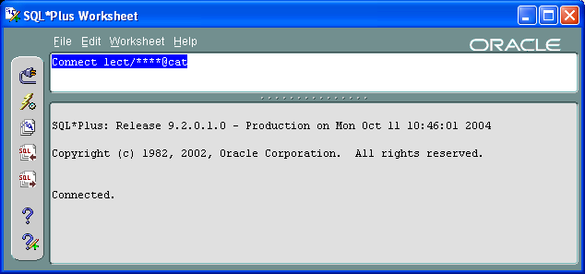
Log on.

Minimise the black window that should appear.

You will now see a screen like shown here →

Make sure it says “Connected” in the bottom window and delete the content of the top window.

The bottom pane shows query results and feedback.

The top pane is where you type in commands using SQL.
- You can edit commands, copy/cut and paste
- Any words Oracle recognises as key words will be coloured in blue
- To run a command, press the F5 key or the "flash" icon
- Make sure old commands are deleted from the top window before you run a new query
- Top Tip: The "SQL←" icon lets you reuse the previous command for editing. “SQL” gives a list of all previous commands to choose from.

Before you start with the queries, you should open Notepad (or Word). Keep a record of your work by copying and pasting from the Oracle input and output panes into the text file as you progress. (In Word, make sure the quotes don’t “go funny”)

In Oracle, we all use the same database (called CAT in our case). Each user has a tablespace within that. Ours is called LECT and contains the database schema below. Your tablespace is currently empty but you will be creating the same database schema in your own Tablespace in Oracle. The idea here is that we have a database that works and you are going to mimic it in your own tablespace.

PERSONNEL
SNUM | SURNAME | JOBTITLE | MANAGER* | SEX | JOINDATE | DIV* | SALARY | BONUS
3016 | BROCK | SECRETARY | 3414 | F | 11-Jul-83 | 10 | 12288
3107 | HAMILTON | SALESMAN | 3200 | M | 13-Dec-82 | 20 | 18534 | 4500
3200 | RAINES | MANAGER | 3812 | F | 01-Jul-80 | 20 | 25872 | 500
3215 | TRINGHAM | CLERK | 3200 | M | 16-Mar-81 | 20 | 9384
3365 | HUGHES | ACCOUNTANT | 3414 | M | 17-Nov-83 | 10 | 23760
3407 | MACRAE | SECRETARY | 3926 | F | 13-Dec-82 | 10 | 16200
3414 | WELHAM | MANAGER | 3813 | M | 22-Jun-87 | 10 | 25872
3488 | STYLES | CLERK | 3365 | F | 01-Dec-82 | 10 | 8652
3698 | FRENCH | CONSULTANT | 3788 | M | 01-Apr-80 | 30 | 20184 | 0
3724 | ADYE | CONSULTANT | 3788 | M | 28-Oct-69 | 30 | 29400 | 825
3788 | KUMAR | MANAGER | 3813 | M | 10-Feb-75 | 30 | 30816 | 1586
3812 | KHAN | DIRECTOR | 3926 | M | 14-Dec-82 | 20 | 42000 | 950
3813 | BATE | DIRECTOR | 3926 | F | 20-Apr-70 | 10 | 46752
3926 | TOWLSON | CHAIRMAN |  | F | 03-Sep-84 | 10 | 45816
3989 | BRAY | CONSULTANT | 3788 | M | 24-Sep-73 | 30 | 18000 | 825

BRANCH
DIV | DIVNAME | CITY
10 | ADMIN | LONDON
20 | SALES | BRISTOL
30 | CONSULTING | LONDON
40 | TRAINING | MANCHESTER
50 | COMPUTING | BIRMINGHAM

TRANSPORT
SNUM* | REGNO | MAKE | MODEL | MILEAGE | DIV*
3107 | G343ALJ | BMW | 316I | 27216 | 20
3200 | F260PQN | FORD | SIERRA | 30986 | 20
3414 | E329WUF | VOLVO | 340 | 28216 | 10
3698 | G181BSS | FORD | SIERRA | 18311 | 30
3724 | G213CBS | FORD | ORION | 20016 | 30
3788 | G268JFN | VOLVO | 440 | 16485 | 30
3812 | H989TNP | TOYOTA | LEXUS | 2193 | 20
3813 | F138RUS | BMW | 320 | 28726 | 10
3926 | G298ALM | JAGUAR | XJ6 | 21817 | 10
3989 | E156EBE | FORD | ORION | 30168 | 30

In the above, underline refers to primary keys and * to foreign keys. Make sure you identify all foreign key/primary key links before proceeding.

Note: In SQL, you create foreign keys ideally at the same time as the rest of a table. Therefore, you will have to choose carefully the order in which you create the tables.
Create tables with no foreign keys first!
Apart from saving your work in Notepad it is also quite a good idea to SPOOL your work. Spooling records every keystroke you make in your session in the lab, which is quite useful to look back on so that you can see all the errors you made and how you corrected them.

To spool your work simply type the following:

SPOOL m:\<path>\<filename> e.g. SPOOL m:\sa0951a\Lab1

The spool file should be empty until you finish your session. After finishing your session there should be a file with a .lst extension that has recorded everything your typed and all the feedback you got from Oracle.

Exercise 5 - Creating Tables in Oracle
It would be a good idea to distinguish our tables from the LECT tables so give them a different name by prefixing them with MY_.

Let’s start with the Branch table. Here is the code to do it. Let’s discuss it then you can type it in. Why are we creating this one first?

create table My_Branch
(div NUMBER(3) NOT NULL,
divName VARCHAR2(10),
city VARCHAR2(10),
constraint div_pk PRIMARY KEY (div));
commit;

Note: The commit at the end is good practice; it makes sure that the creation is completed properly. You should use it whenever you make design changes or add data.

Now type
DESC My_Branch

This simply shows the structure of the table that you have just created. You will probably need to scroll to the right to see it.

Now ask yourself which table you would create next. PERSONNEL or TRANSPORT? Notice that these two tables both have two foreign keys. Personnel has DIV and MANAGER (which links to the primary key of the same table!) and Transport has DIV and SNUM.

You will need to know how to create a foreign key for these tables so here is the general syntax to do this.

constraint <constraint_name> FOREIGN KEY (<column(s)>)
REFERENCES <table_name>(<column(s)>)

Use DESC on the original tables in the LECT tablespace (e.g. DESC TRANSPORT) to find out which datatypes you should use!
Apart from VARCHAR2 and DATE, you will also need the NUMBER data type.

Now create the other two tables.

What’s next?
Well we have started to create the structure of the database but we haven’t got any data into it yet. We need to:

- get data into the database
- know how to change the database (ALTER, DROP commands etc)
- know how to do clever alterations to the database automatically to ensure the integrity is not violated when something is deleted.

Skills and concepts you should have picked up now:
- Relation modelling
- Integrity constraints
- Anomalies
- Creating Oracle tables
- Finding your way around SQL*Plus an SQLWorksheet and Oracle URL
- DESC command to look at table definitions

*********************************************************************
HOMEWORK. Please complete this within the next week.

Exercise 1 – Setting up your database
We want you all to keep up with the pace of the module, so if you experienced any difficulties in the lab here is your chance now to relax in your own time and increase your learning. At this stage you don’t have any data in your database but make sure that:

- your tables are all named correctly with MY_
- your primary and foreign keys are all implemented
- you have saved the code for creating your tables on your M drive
- you know how to SPOOL correctly

Exercise 2
Download the Additional labsheet from Webct and make sure you complete it.
*********************************************************************

