SA0951A: EERM Modelling and Mapping
Remember to prepare these exercises before the tutorials next week and bring your notes to class with you.

Exercise 1 – Part A
a) Identify and explain the errors in the super/subclass structure below.
b) Redraw the EERM more appropriately without losing any of the information. (remember these diagrams can include other structures besides the class structures).
VEHICLE
registration{pk}
colour
trailerSize

CAR
HGV
OWNER
taxDate
numSeats

maxHaulage
taxDate
engineSize

address
age

{Mandatory, AND}
Notes: HGV = Heavy Goods Vehicle (lorry)
If you are unsure about any of the attributes used, make your assumptions clear about their meaning. You can include additional attributes too if you wish.

Exercise 1 – Part B
Now map your revised model. You will need mainly Step 6 of the mapping process.

Exercise 2 – Part A
The University wants to design a database for its rooms. There are different kinds of room – lecture theatres, computer labs, tutorial rooms, staff offices, …(and more). For all types of teaching rooms, the details stored include the number of students it can hold, and facilities such as OHP, data projector, etc. For Computer labs, also record any specialist software available, and whether there is a printer. For staff offices, record the staff member(s)’ names, PC identifiers and phone numbers. Use your own knowledge of the rooms you have used at Abertay in order to build your EERM. Your answer will reflect your view of how you think rooms at the university should be classified for database usage. Note that this EERM can be constructed entirely as a super/subclass structure.

Exercise 2 – Part B
Now map the agreed model, using mainly Step 6 of the mapping process.

Exercise 3
The EERM below is a possible representation of this package holiday scenario:

Each unique holiday code refers to a holiday package, which uses one or more places of accommodation and is booked through a travel agent. Accommodation includes several different categories, such as hotel, ship, self-catering. For each accommodation, we want to know the facilities offered (such as swimming pool, childcare, etc). Also, each Hotel and self-catering apartment is in a resort.

a) Study this EERM with the description to make sure you understand it fully. Ask any questions you may have about this.

b) Now map this EERM into a relational model. Once you have your answer, check all primary and foreign keys.
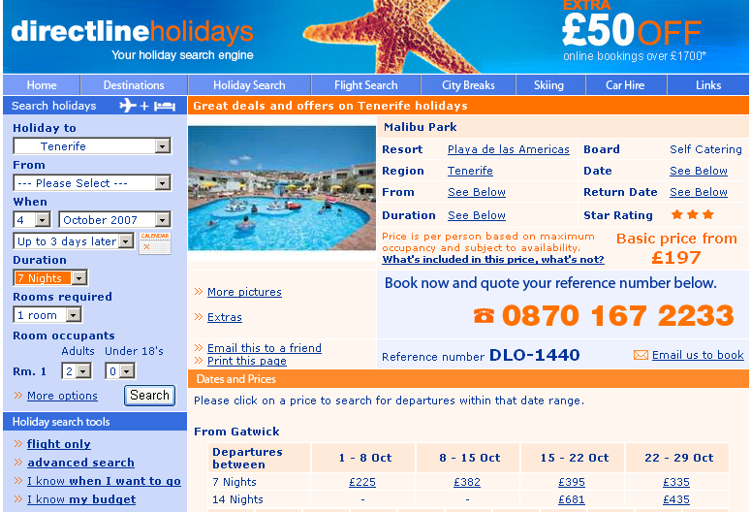
In case you don’t know at all what we mean by package holiday etc, this screenshot form an online brochure may help (http://www.directline-holidays.co.uk/Malibu%20Park%20Deal, accessed 3/10/07)

