Staffordshire University
MODULE/COURSE UNIT MONITORING REPORT

To be completed for each module or discrete course unit.

Section A: Module/Course Unit Details

Module Code  CE00407-3 | Module Level  3 |  | Academic Year  2009-10 | Delivery Location(s)  Stafford
Module Title: Management of Database Systems |  |  |  | Teaching Block two
Module/Course Unit Leader: Clare Stanier  Other Teaching Staff: Euan Wilson |  |  |  | To which awards does this module/unit contribute:  Option module on Computing Degree Scheme and BIT scheme  Core for Stuttgart students
Have any changes been made to this module/unit in the current academic year e.g content/learning strategy/assessment/learning outcome?  If yes, please say what the changes were: The module descriptor was revised following the first delivery of the module in 2008/9. The purpose of the revision was to remove overlap in content with CE00332-3 |  |  |  | YES
For Faculty/School Office Use Only: |  | # of students enrolled at start of module
 |  | # of students not submitting
 |  | # passed at first attempt
 |  | # of students referred
 |  | # of students passed by referral board

Section B. Process

In this box please indicate how you gained feedback from students.
There were no completed on line evaluation forms. The course team had devised a questionnaire to ask for comments on the module format and this was completed by 2/3 of the students on the course. Feedback was also obtained by discussion with students, particularly in the Milestone sessions and in practicals.

Section C: Student responses

Identify the most frequently expressed positive comments  (indicate frequency of each specific comment): | Identify the most frequently expressed 'improvement' comments (indicate frequency of each specific comment):
The main aim of the questionnaire was to find out if the milestone was regarded as useful – students (100%) were emphatic in their appreciation of the milestone element | Some students asked for a larger word count on the milestone. The word count is restricted to reduce the amount of work required from students for the milestone but we will look at extending the word limit for next year.
We asked if the proof of concept artefact should become a more substantial artefact – students commented that ‘Enough was shown allowing more research’ ; ‘ ‘the size of the artefact is just about right’; ‘no, some topics aren’t good/easy to demonstrate’ ; ‘about right’; ‘ It was fine. It supported the report well’ and ‘No (8)’ | ‘yes, as it will allow to demonstrate a better understanding of the content covered’  ‘Yes, as it was a bit difficult to bring point across as was not a real system’  ‘yes but I guess I wouldn’t have made it with the time’  On this basis, we will keep the artefact as it is for the next delivery.
We wanted to find out if the practicals were perceived to support the lecture material.

Strongly agree -4
Agree -8
Agree in Part -6
Disagree -3
Strongly Disagree 0

And if the practical material was covered in sufficient depth

Strongly agree -2
Agree -9
Agree in Part -5
Disagree -2
Strongly Disagree 0

This was the only area where the responses indicated a need to review the module delivery. (see below)

We wanted to find out if the students found the module challenging or if it was pitched at too low a level.

Level about right -7
Challenging -7
Very Challenging -5

On this basis, and supported by the results which were good but not exceptionally so, the module level will remain the same for next delivery
There was a general comments section which most students did not complete. 3 general comments were received however. (Note that all questionnaires were anonymous)

‘very interesting module, taught brilliantly that engaged all the way providing an insight into DBs in the real world’

‘Module was interesting – felt a bit more database issues could have been discussed as a group. But generally very beneficial to do at level 3’

‘Thank you for the great module’

Section D: Interpretation & Action Points

Interpretation

(1) Summarise your experience as module leader and your interpretation of the student feedback and any external examiner comments.

This was a satisfactory module from the staff point of view – interesting and challenging - and seems to have been enjoyed by students. For a number of reasons this was a very good cohort of students; they were willing to engage, worked hard and were prepared to go beyond the taught material. Some of the coursework was to a very high standard; other assessments were not to the same standard, but all the students who passed could explain what they had written and their PoC artefact in the presentations. Two students failed due to partial submission for reasons outside the control of the module.

(2) What is your evaluation of any changes you have made this year in pedagogy, outcomes and assessment?
The change to the module content has worked well in that it removed the overlap and allowed us more time to look at in depth at current db developments. This was the second delivery of the module and there were minor revisions to delivery – the milestone was more in depth than in the first delivery, practicals covered a wider range of topics and in more depth.
Action Points

In light of your experience of delivering the module this year what changes do you propose at the first possible opportunity. Please indicate if these changes require formal Programme Amendment approval.

The relationship between lectures and tutorials will be reviewed to make sure that the link is clearer to students. Time limitations mean that it is difficult to cover practical topics in more detail but we will review the extension exercises given to students. All the practicals include suggestions for further work. Based on discussions with students, the team believes what is being requested is more lower level practice exercises rather than more depth at advanced level. This may reflect the fact that 5 students found the module very challenging

Module Statistics

Distribution of Coursework Grades

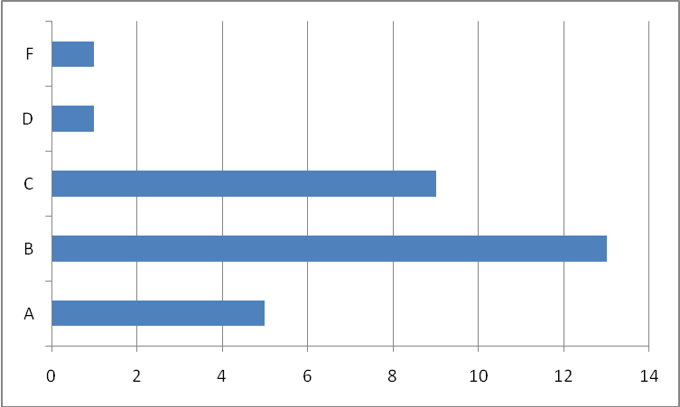

Distribution of Exam Grades

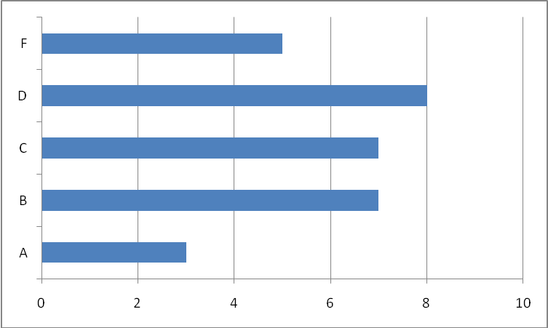

Overall Module Grades

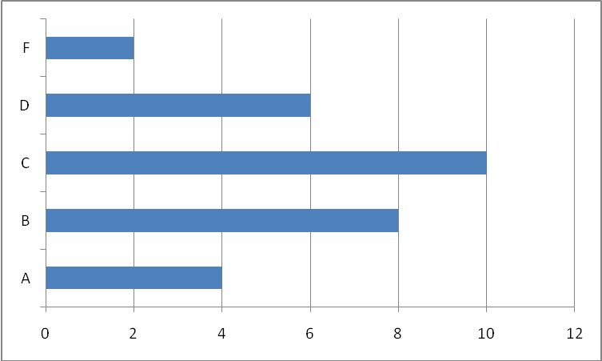

PLEASE PASS THE COMPLETED FORM ON TO THE APPROPRIATE
FACULTY/SCHOOL ADMINISTRATIVE STAFF
AND TO THE RELEVANT AWARD/COURSE/SCHEME LEADERS

