Management of Database Systems CE00407-3
Assessment Structure

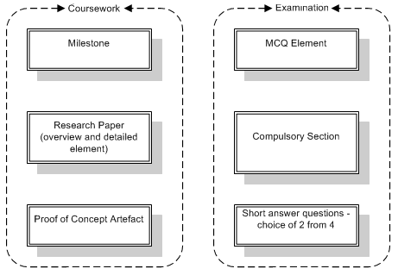
The coursework and exam are both weighted at 50% of the module. The coursework consists of the milestone, a research paper and a proof of concept artefact; the exam has an MCQ element, a compulsory 40 mark section and a short answer question section. The coursework topic will change year on year but for 2009/10, the topic was database security. The coursework mark scheme is posted on the VLE.
Coursework
- To complete the research report, students are required to give a general overview of database security issues and techniques and to research one aspect of database security in detail. Students choose for themselves which aspect of security they wish to review - the milestone was used to make sure that students had understood what was required. The research report is supported by a proof of concept artefact - a small piece of practical work produced by the students to demonstrate how the topic they have reviewed in detail is applied in implementation practice. For example, a number of students decided to research database encryption and produced sample artefacts to demonstrate that encryption was, or was not - conclusions varied with the artefact created and the data used - an appropriate security technique in a given situation.

- In undergraduate assessments, more is usually better. This meant that the 'proof of concept' idea was initially difficult for some students who expected to build a full database. To help the students understand the assessment, one of practicals was written as a 'proof of concept' artefact to demonstrate what was required. 'Proof of Concept' was used to build a practical element into the assessment without requiring too much work from the student.

- The coursework was assessed through the written report and by means of a practical demonstration in which the student answered questions based on the report and on the artefact. This allowed us to be confident that the students understood what they had written and provided an inbuilt check for plagiarism. The students were aware that the demonstration would be marked on the 'if you wrote it, be prepared to explain it' principle.

Exam
- The MCQ element was included to assess breadth and to discourage question spotting. To help revision and demonstrate the format, a large number of MCQ practice tests were provided in the VLE. The MCQ section accounted for only 20% of the exam marks – any more would not be acceptable in a L3 paper.
- The compulsory question and short answer questions were included to assess depth. Students were given the topic for the compulsory question and were advised on what to revise.
- The exam was based on the principle that assessment should measure understanding, not just memory. Students were told that exam questions would be scenario based and that exam answers must provide evidence of further research and must be relevant to the scenario - this was to avoid 'note dump' style answers. As scenario based exam questions were new to most of the students, particularly to the students from Stuttgart, the students were given example questions to work through and this was covered in the exam revision lectures.

