Capturing and Disseminating Usability Patterns with Semantic web technology
Scott Henninger, Mohamed Keshk, Ryan Kinworthy
Department of Computer Science & Engineering
University of Nebraska-Lincoln
{scotth, mkeshk, ryank}@cse.unl.edu

Introduction and Motivation
Our research has focused on tools that help deliver patterns (and usability guidelines) to software developers during the development process and developing a repository that is refined through project experience [Henninger 2000]. In the following, we will give a brief overview of the issues we are addressing in this area, taking the position that large-scale deployment of patterns with explicit contextual representations have the potential to become a significant tool in both the software development process and the scientific understanding of usability for software applications.
Drawing on the success of patterns in the architecture and software design communities [Borchers 2000; Gamma et al. 1995], usability patterns have emerged as a problem-oriented alternative for disseminating usability knowledge [Erickson 2000]. While the current emphasis on the design of usability patterns is necessary [van Welie 2002], a number of other issues have yet to be explored in detail. First, given current software development and usability processes, efforts to apply patterns fall short of the goal to put the accumulated knowledge of user-centered design at the fingertips of software developers. Just as with usability guidelines, it is frequently the case that only human factors specialists often use patterns, often as a tool to ensure conformance to standards once the interface has been built, which is often too late to fix significant interface problems.
Second, current approaches to representing patterns are document-based, at best supported with hypertext tools on the Web. These passive representations rely on individual developers or usability specialists to know of the existence of the resources and understand when they should be applied. Given the potentially copious numbers of patterns that can be used in different contexts, and the lack of training in usability issues, this is not a satisfactory solution. Last year’s CHI patterns workshop demonstrated that even human factors specialists find it difficult to apply abstract patterns to specific design problems.
Third, mechanisms are lacking to turn the currently isolated sets of patterns and pattern collections into a pattern language [Alexander 1979], an interconnected corpus of knowledge that is agreed upon by the community. Tools and techniques are needed to create a community of practice to continuously evolve and refine available usability patterns.
Fourth, which closely coupled with the third issue, is the problem of validation. A certain degree of discipline is necessary to write good patterns and ensure they are appropriate for commonly occurring design problems [Vlissides 1997]. Yet, particularly in the usability milieu, patterns that work well in one context may not be useful in another context. Methodologies and tools are needed that balance the need for discipline while acknowledging the importance of contextual relationships and the fast pace of change in business practices and technology.

An Architecture for Capturing and Using Usability Patterns
To address these issues, we have been working on tools and methodologies that leverage Semantic Web technologies with a flexible validation process to create an infrastructure that allows the world-wise capture and use of usability patterns. The architecture involves three components, a Web-based ontology for representing patterns, agents that compute on the Web-based ontology to support the development process, and a distributed mechanism for validating patterns. Each of these is described in the following sections.

Representing Usability Patterns
The Semantic Web is the idea of having data on the Web defined and linked in a way that can be processed by both humans and machines [Berners-Lee et al. 2001]. Semantic Web technologies, such as RDF [Klein 2001], DAML [Burke 2002], and OWL [McGuinness, van Harmelen 2002], are built on top of XML, providing enhanced capabilities for expression of meaning and knowledge representation in the WWW. The creation of ontologies, an explicit formal specification of how to represent the objects, concepts and other entities in a specific domain of interest and the relationships that hold among them [Berners-Lee et al. 2001]. This formal representation facilitates the creation of agents that can compute while retaining human readability [Berners-Lee et al. 2001].
An ontology in a Semantic Web language consists of a set of classes arranged in a class-subclass hierarchy. Each class can have a number of member objects, each of which has specific value for the attributes defined in the class. References between objects (and classes) are supported, providing typed relationships between objects.
For example, Figure 1 illustrates an ontology of usability patterns taken from vanWelie’s design interaction patterns [van Welie 2002]. The screen image is taken from Protégé [Noy et al. 2001], a tool that allows the creation of ontologies in an abstract format that can be converted to specific Semantic Web languages through a plug-in architecture. The left-hand pane shows the class hierarchy and the middle pane shows six objects of a specific class (Searching in the class hierarchy). The panes on the right-hand side of the figure show some of the attributes for the Searching class and the values of the object chosen in the image, “Advanced Search.”

Inferencing using Semantic Web Representations
Semantic Web Ontologies are specifically design for computation by agents. For example, the relationship that using one pattern requires the use of another pattern can easily be represented, as shown in the Requires attribute of Figure 1 (note that his cannot be accomplished in HTML or XML, which are stand-alone documents at most linked by an untyped hypertext link). In addition, inference engines are built on top of the ontologies that retrieve and extract grounded facts that are already declared in the ontology. Many such inference engines have already been built that ate capable of transitivity and other inferencing capabilities using Semantic Web query languages. This provides a degree of intelligence in finding relationships amongst usability patterns that can be used to find applicable and/or useful patterns.
The scenario depicted in Figure 1 demonstrates how this technology can be used to help software developers design an e-commerce application to be deployed on the Web. The developers would use this ontology to find usability patterns that meet their needs. The ontology can then push them along a process to find other patterns that may be of use in the overall deign process (note in the ontology, marked “Classes” in Figure 1, that patterns from many parts of software development are included in addition to usability patterns).
We do not envision that developers would use the ontology in this form. Instead, Web-based ontologies would be embedded in various design tools to enhance the support and knowledge provided by the tool. Semantic Web technologies are well-suited for this kind of relationship building and can be posted on the web, such as in DARPA’s Defense Agency Markup Language [Burke 2002] for easy reference and extension.
In our scenario, the developers use the pattern tool’s rule based system (agent) to define the basic parameters of the website’s design. Once the pattern tool knows the context for the design, it can make inferences about which fundamental patterns the developers should be using as a foundation on which to build the rest of the website. An example session is shown in Figure 2, shows an initial approximation of what can be accomplished by such a tool. After initial requirements gathering, through a question/answer session or a formal requirements process, an initial set of patterns are found. Each of these patterns can then find related patterns to help fill out the design until the designer is satisfied enough information has been gathered to start prototyping and implementation efforts. Figure 2 shows three of the Searching objects shown in Figure 1 ach with a unique set of attributes, i.e. a unique representation of the context in which these patterns should be used and the relationships to other patterns.
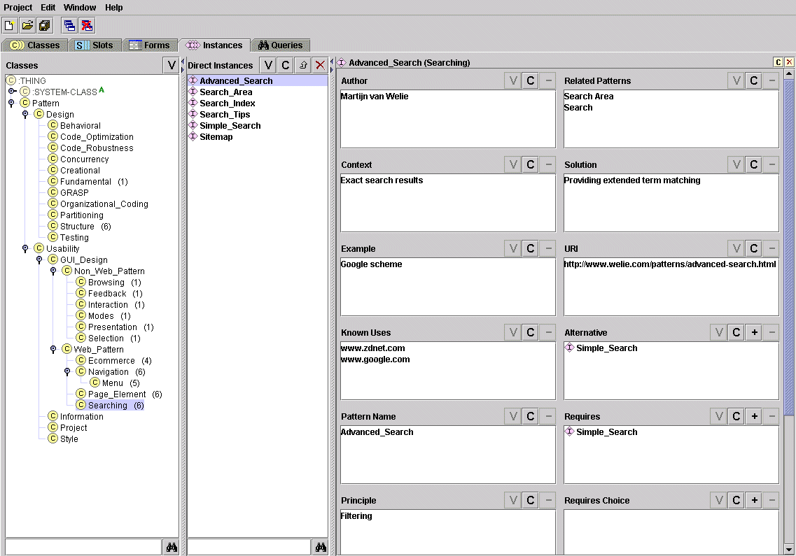
Figure 1: An Ontology Represented in Protégé.

Pattern Validation
The last component of this architecture is necessarily human-driven. While inferencing can find useful relationships amongst patterns, the validation of good usability patterns will largely be a matter of people assessing patterns against experiences and through use. We envision a process similar to that of Answer Garden [Ackerman, Malone 1990], where new pattern proposals are routed to a distributed set of experts in different usability areas. These experts can then provide feedback to pattern creators, point new pattern creators to similar patterns, and otherwise facilitate the process of creating a useful set of patterns in ontological formats. This would include not only the pattern instances but modification and refinement of the repository as new patterns emerge (i.e. are found, not created [Gamma et al. 1995]).

Conclusions and Future Directions
Continued research is needed to further understand the potential of this combination of intelligent Web-based technology and semiformal representations of design and usability patterns. The overall goal is to both create a world-wide corpus of software usability knowledge, capable of systematically capturing the accumulated and growing wisdom of the HCI community, while providing the infrastructure for creating design tools that proactively apply usability and design patterns early in the software development process. We have only taken small steps in this direction, and hope that future validation and use of our approach provide more information of usability knowledge and the contextual factors that impact this knowledge.
Figure 2: Inferences for Three Different Web Site Search Patterns.

References
[Ackerman, Malone 1990] Ackerman, M.S., Malone, T.W., "Answer Garden: A tool for growing organizational memory." Proc. of the Conf. on Office Information Systems, (1990), ACM, New York, 1990, pp. 31-39.
[Alexander 1979] Alexander, C. The Timeless Way of Building. Oxford Univ. Press, New York, 1979.
[Berners-Lee et al. 2001] Berners-Lee, T., Hendler, J., and Lassila, O., "The Semantic Web." Scientific American, May 2001, 2001.
[Borchers 2000] Borchers, J., "CHI Meets PLoP: An Interaction Patterns Workshop." SIGCHI Bulletin, 32 (1), 2000, pp. 9-12.
[Burke 2002] Burke, M., The DARPA Agent Markup Language Homepage, DARPS, http://www.daml.org/2002.
[Erickson 2000] Erickson, T., "Lingua Francas for Design: Sacred Places and Pattern Languages." Proc. Designing Interactive Systems (DIS 2000), (New York, 2000), 2000, pp. 357-368.
[Gamma et al. 1995] Gamma, E., Helm, R., Johnson, R., and Vlissides, J. Design Patterns: Elements of Reusable Object-Oriented Software. Addison-Wesley, Reading, MA, 1995.
[Henninger 2000] Henninger, S., "A Methodology and Tools for Applying Context-Specific Usability Guidelines to Interface Design." Interacting With Computers, 12, 2000, pp. 225-243.
[Klein 2001] Klein, M., "XML, RDF, and Relatives." IEEE Intelligent Systems, 15 (2), 2001, pp. 26-28.
[McGuinness, van Harmelen 2002] McGuinness, D.L., van Harmelen, F., Feature Synopsis for OWL Lite and OWL, W3 Consortium, http://www.w3.org/TR/2002/WD-owl-features-20020729/, last accessed: Nov. 2002.
[Noy et al. 2001] Noy, N., Sintek, M., Decker, S., Crubezy, M., Fergerson, R., and Musen, M., "Creating Semantic Web Contents with Protege-2000." IEEE Intelligent Systems, 16 (2), 2001, pp. 60-71.
[van Welie 2002] van Welie, M., Guidance/Feedback Patterns, http://www.welie.com/patterns/index.html.
[Vlissides 1997] Vlissides, J., "Patterns, The Top 10 Misconceptions." Object Magazine, 1997.

Semantic Web technologies and languages are currently in a state of flux, with RDF (Resource Description Framework), being currently most dominant. Emerging technologies, such as OWL (Web Ontology Language) combine static document representations with logic constructs that can be incorporated into the Web-based documents.

