Tool-based Decision Support for Pattern Assisted Development
Perspectives on HCI Patterns: Concepts and Tools
Workshop at CHI 2003, Fort Lauderdale, FL, 6-7 April

Sharon L. Greene, Paul M. Matchen, Lauretta Jones, John C. Thomas, Matt Callery

IBM T.J. Watson Research Center

Hawthorne, NY, USA
{slg,jonesla,matchen,jcthomas, mcallery}@us.ibm.com

In a companion position paper for this workshop ‘HCI-Friendly Middleware: A contexualized Pattern Language Approach‘ we discuss how a pattern can be a useful vehicle to encapsulate the essence of a recurring problem, its analysis and solution. Problems and known solutions within the realm of Human Computer Interaction extend across a broad spectrum varying on several known dimensions or characteristics. Dimensions related to user characteristics (e.g., age, computer skill level, domain expertise), contexts of use (e.g., learning in a classroom, office, or public kiosk), domain (e.g., entertainment, pedagogy, or programming), task characteristics (e.g., transaction oriented, exploration oriented, creative production oriented), and technologies (e.g., desktop computers, PDAs, cell phones, etc.) are a few examples of the rich and complex variables that may determine not only particular problems, but different solutions.
It is still an open question as to the relationship of such variability to HCI patterns. Should there be different patterns, and perhaps even pattern languages, geared towards a subset of this variability or can there be general patterns that relate to problems that perhaps require different solutions depending on values of these variables? Should there be separate patterns, say, related to ‘screen legibility’, dependent on age or should there be one pattern, with different solutions and different examples? Whichever of these approaches is taken, the usefulness and usability of the resultant pattern or patterns will be dependent on the successful resolution of many of the same requirements – particularly those related to the ability to find and use the knowledge that is appropriate to one’s goals. We believe that determining the applicability and relevance of patterns to one’s task or goals – be it as varied as system design, communication, or learning – will be critical to both the usability and usefulness of patterns. This means there needs to be a mechanism to help the pattern user take what he or she knows about the problem in hand, and express it in a way that enables him or her to seek, find, and evaluate the applicability of the selected patterns to that problem.
At this point we are taking a fairly agnostic approach to the properties or structure a pattern should have, as well as to other issues, such as whether there is an optimal degree of homogeneity along various dimensions (e.g., user characteristics, context, etc.) for a pattern language. We are striving instead to create tools that support what we believe to be critical activities that will in turn, help shed light on some of these more conceptual issues. We are striving to help improve the usefulness of patterns of various types and structure, by enabling the designer or developer to search pattern sets and pattern languages to find patterns that relate to their known requirements or needs.
To this end, we have begun development of a prototype tool to support pattern-assisted design and development. The tool supports the pattern creation process, the browsing, viewing, and editing of patterns, but most importantly, it provides decision support to help filter and select patterns based on criteria or drivers specified by the pattern authors as relevant to particular patterns.
Internally, patterns are stored as XML documents. Pattern elements are the fields or properties of the patterns (e.g., ‘Name’, ‘Problem’, ‘Forces’, ‘Context’, ‘Solution’, etc.). There is a default set of such properties, but, since there is of yet no accepted standard set of properties, this set is definable and extensible by the pattern language author. Within the tool one can define different pattern types – with different fields. In addition, links between patterns may be user defined and typed.
This degree of flexibility permits the evolution of the patterns, and enables exploration of the effectiveness and usefulness of different pattern formats. It also permits the addition of fields with enumerated values that can be used in the tool to help the pattern users move from the requirements they have to the patterns they need.
Below is a snapshot of a sample interaction with our tool. Patterns that have been created with the tool are linked to one another and shown in a graph. Individual patterns may be edited, (the edit window is shown here), or simply viewed in a non-editable mode.
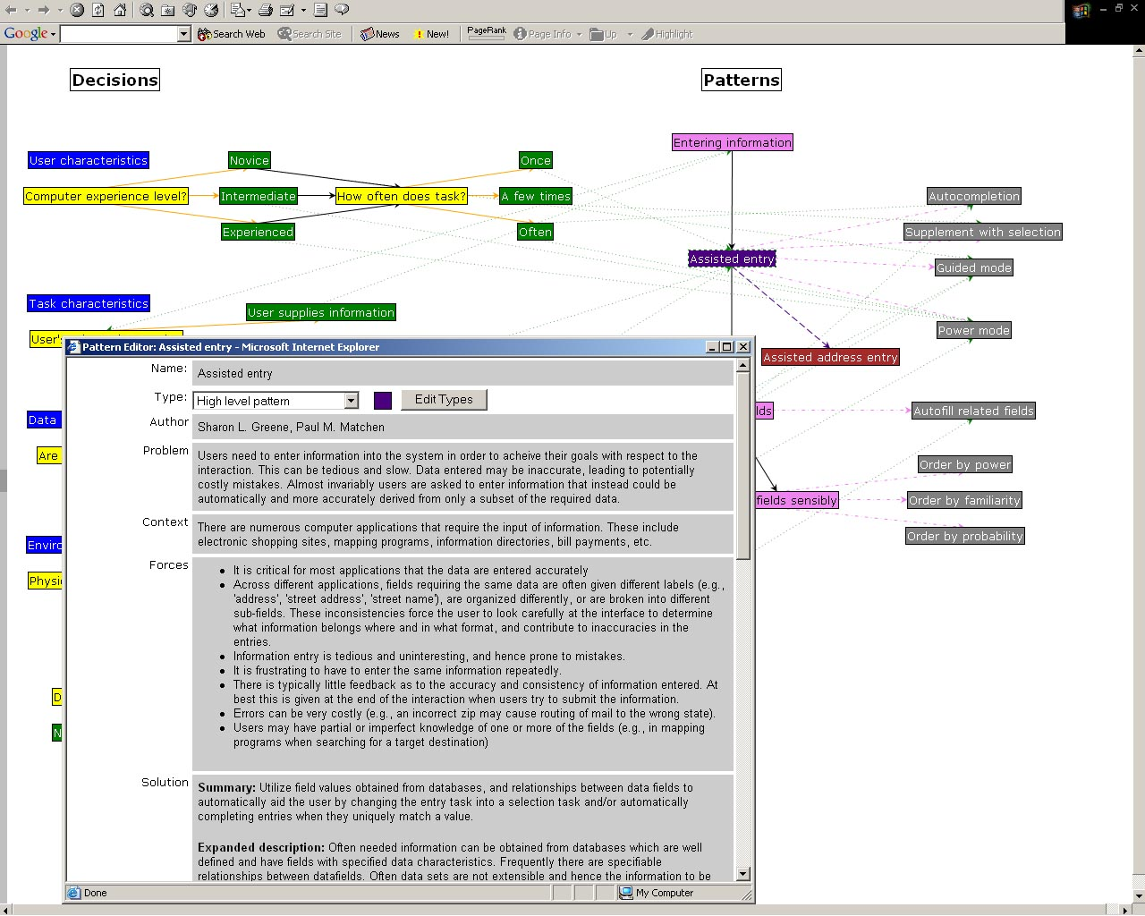
Using the tool, one can search for patterns that contain specified strings in all, or any subset of the fields of the patterns. In addition, there are currently two other decision support mechanisms embodied in the tool.
The first is the creation of an ‘advisor’ based on a decision tree that the patterns author can create manually. This consists of adding ‘question types’ and ‘answer types’ and linking the answers to patterns they deem relevant, based on the answers. In the above example, there are question nodes that relate to user, task, data, and environmental characteristics. Different answers point to different patterns. The tool then automatically creates an ‘advisor’ based on these question/answer nodes, and their linkages to the patterns. These relationships may be explored graphically, by viewing the tree, or by stepping through the question and answer ‘advisor’ part of the tool.
As an alternative, we have enabled the addition of properties into the patterns that can be marked as relevant as drivers for pattern selection. So, for example, a pattern related to ‘Assisted Entry’ might have a field ‘Device’, that is an enumerated type with values such as ‘desktop, touch screen, pda’ among others. A question may be associated with this property and the property can be marked as relevant to ‘use as driver.’ The tool will then automatically create a set of, essentially ‘decision tables’ that one can use to specify values on properties set in various patterns. A user of the tool may then input values on these properties and the tool will gather the patterns that meet the selection criteria specified. An example of this may be seen below, using the IBM Patterns for e-business.
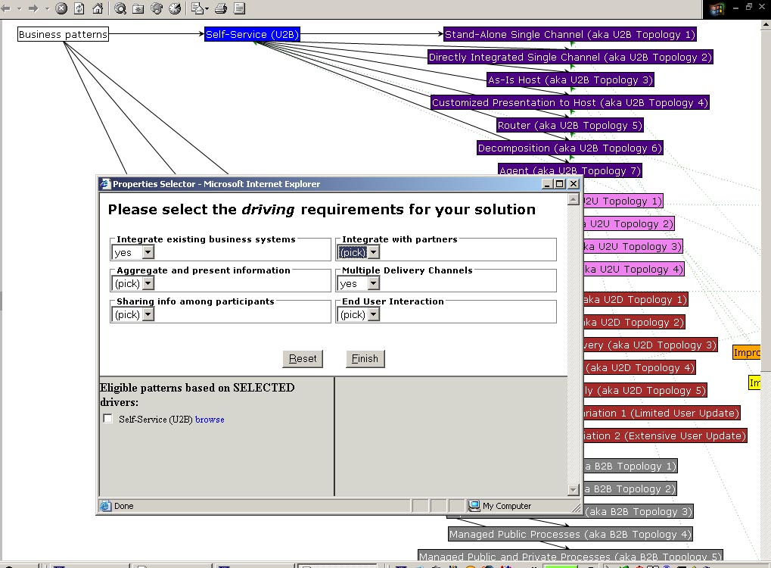

There are lot of open questions that we are exploring related both to the user interface and the underlying functionality that is needed to further our goals of supporting pattern creation and pattern use as a means to improve the design and development process. We hope that the issues that arise in creation and use of this prototype tool will in turn also help shed light on some of the more conceptual issues related to pattern structure, pattern use, and pattern usefulness.

