4. CUSTOM 3D ACTION BUTTONS

Here's a good example of Custom 3D Action Buttons. Note how the buttons look like you can press them. Also note how the accompanying text makes it clear what the images represent. (http://www.yahoo.com)

Anyone who has surfed the web knows that images can also be used as links. However, not all images work well as links. This pattern describes several techniques for making images that are also effective links.

You’ve arrived to a web page that, visually speaking, is quite astounding. The page is artistically appealing, making good use of many images. There seems to be no visible links on the page, though. “All right”, you think to yourself, “now where is their product information page?” You move the mouse over to some image and click. No, that’s not a link, since nothing happened. You move your mouse to another image and click. Nothing happens again. Frustrated, you click on another image, and finally, you manage to get to another page. Only, it’s not the page you wanted.

We’re sure you’ve seen pages like this before.

There are lots of pages out there that look great but are really hard to use. Let’s pretend for a minute that your web pages are like the one described above. Pages with lots of images can take a long time to download. How long are your visitors going to wait for the page to download before they hit the Back button? Will the images contribute to their overall experience? Do the images help make navigation easier?

In many cases, the images are just eye candy, and don’t enhance the user experience in any significant way.
However, the other extreme, having no images at all, can be boring. Fortunately, this isn’t an either-or situation, where you have to choose either aesthetics or usability. That’s just a straw man argument. The real issue here is how to achieve an effective balance between the two.
No images
Blue links only
Custom 3D
Action Buttons
Custom 3D Action Buttons combine text with graphics,
and are a good way of balancing aesthetics and usability.

One technique that works well in practice is to use specialized images that look like they can be pressed. We call these images Custom 3D Action Buttons. Custom 3D Action Buttons let you use images on your web pages, but also provide cues for which images can be pressed. Simple Custom 3D Action Buttons can be made fairly easily in most paint editors. More sophisticated ones will take more time and skill, though. We won’t go into the details of how to make these icons. Instead, we provide some rules of thumb for making effective Custom 3D Action Buttons:

1. Make your most important images look like buttons you can press. As we said above, one of the most common problems on the web today is that people do not know what images can be pressed. People have to move the mouse all over the page, looking for the cursor to change, or see if a new URL is displayed on the bottom of the browser, or see if there is a change in graphic (called a “rollover”). However, people already know what physical buttons look like. Custom 3D Action buttons just leverage knowledge of the real world. Buttons draw the eye, providing visual cues as to what can be clicked.

However, you don’t want to overdo it! Having too many buttons can make navigation slower, since you spend most of your time looking for the right one. One strategy is to group related buttons together. For example, in the image below, Netscape makes its Chat, WebMail, My, and Download buttons look similar. We recommend having at most six icons in a group, for the same reason. Having too many buttons in the same group will make it harder to find the right one.

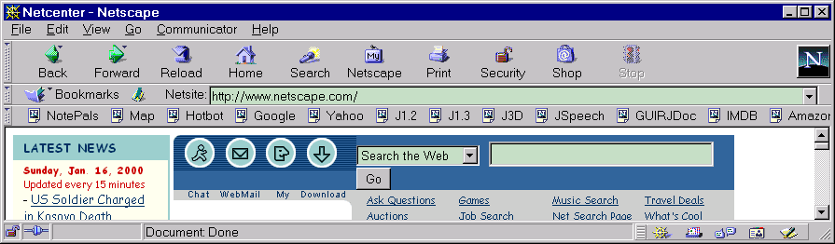
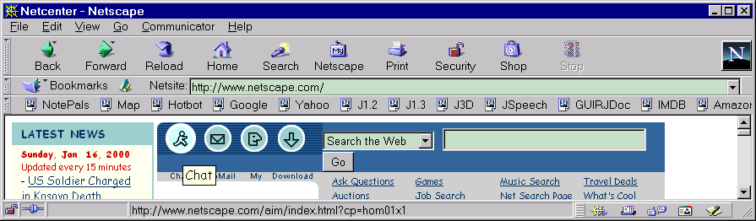
2. Make buttons that have similar functions look similar; make buttons that have different functions look different. For example, don’t make your “Purchase” button look like the buttons used for navigating your web site. Buttons that have similar functions should be similar in size, color, shape, or location. Likewise, buttons that have different functions should be different in these features.
Netscape NetCenter uses text, tooltips, and highlighting to help identify icons.
(http://www.netscape.com)

3. Add text where possible. One drawback to using icons is that people often don't remember what they mean. Text can be used along with an icon to help your visitors. The text can either be part of the graphics image, or can be part of the HTML. It is much easier to align text with the image when it is part of the image, though it may cost a slightly longer download time. On the other hand, since HTML is faster to download you might experiment with it instead, though it is harder to align correctly. One common technique, used in the Yahoo! screenshot, is to use smaller text as part of the graphics. Note that even though the text is part of the image, it is still appears as a BLUE LINK (1). In the Netscape screenshot to the right, the text is separate from the image.

One alternative to having text always being displayed is to have it appear as a tooltip. That is, the text is not displayed unless the mouse is over the image. We recommend against using tooltips by themselves, since people will have to move the mouse over every image to see if there is a tooltip. An effective technique is to combine tooltips with text descriptions of icons. This way, visitors can see the short descriptions, and move the mouse over the image to get a longer description.

One important thing to keep in mind when designing is SITE ACCESSIBILITY (19), since not all users are capable of using the standard desktop web browsers.

4. Shrink images, and merge images together. Since these buttons are graphics images, it will take more time to download them than it would if BLUE LINKS (1) were used. It will take even longer to download if rollovers are used, since multiple images must be downloaded. You can address this problem by using SMALL IMAGES (83), combining images into a SINGLE IMAGE NAVIGATION BAR (23), and generally keeping a LOW NUMBER OF FILES (82). Another compromise is to use Custom 3D Action Buttons sparingly, only on your most important links.

5. Don’t make Custom 3D Action Buttons too big or too small. If your buttons are too small, then they will be hard to see and hard to click on. If your buttons are too big, they will be easier to click on, but will also take up too much screen space. You’ll have to decide the size of your buttons on a case-by-case basis, but we recommend a minimum size of at least 20 x 20 pixels.

Team
Get the following people involved in the design of your Custom 3D Action Buttons: Information Architect, Art Director, Graphic Designer, Illustrator, and HTML Programmer

