Constraint Diagrams Editor – User guide

1. How to install

Before installing the editor check if the Java environment is installed and set the variable JAVA_HOME to point to directory that contains the binaries of the Java environment.
- Download the kit from www.cs.kent.ac.uk/projects/rwd
- Unzip the file in the desired directory
- Run the startEditor.bat file from the bin directory.

2. Menus

2.1 File menu

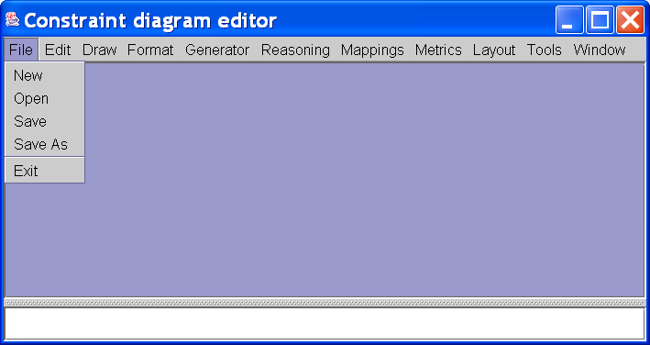

New: Creates a new, blank diagram
Open: Opens an existing diagram
Save: Saves the diagram in the current frame.
Save As: Saves the diagram in the current frame into a different file.
Exit: Exits the editor

Open works on diagrams saved using or xml or binary files (cd). Save and Save As can be used to store diagrams in xml, binary, jpg, png and eps.

2.2 Edit menu

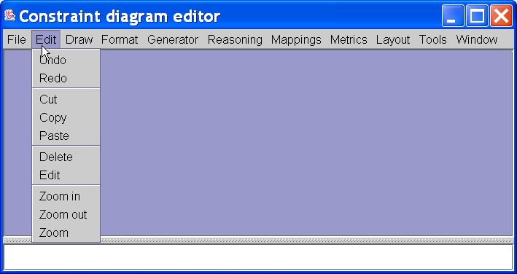

Undo and Redo: Usual editing functions.
Cut, Copy and Paste: Usual editing functions that use clipboard.
Delete: Deletes the selected items from the current frame.
Edit: Pops up a window that allows the user to edit a decoration box or a comment.
Zoom in, Zoom out, Zoom: Provides support for zooming.

2.3. Draw menu

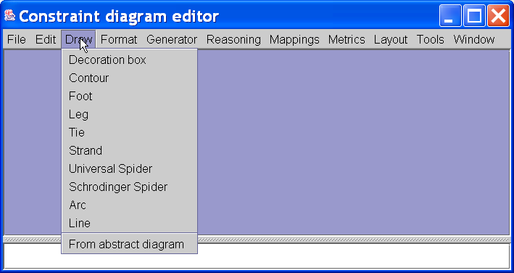

Decoration box: Adds a decoration box.
Contour: Adds a concrete contour
Foot: Adds a spider foot.
Leg: Adds a normal spider leg.
Tie: Adds a tie.
Strand: Adds a strand.
Universal Spider: Adds a universal spider.
Schrodinger Spider: Adds a Schrodinger spider.
Arc: Adds an arc.
Line: Adds an arrow.
From abstract diagram: Builds a concrete diagram from an abstract diagram.

In some of the cases a windows pops up to allow the user to enter other attributes of the shape (e.g. label). The position of the cursor is used to determine the location of the new shape.

2.4 Format menu

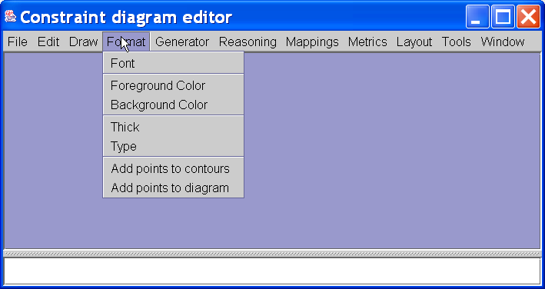

Font: Sets the font for the selected items
Foreground Colour: Sets the foreground colour.
Background Colour: Sets the background colour.
Thick: Sets the tick of the line that is used to draw the shape.
Type: Changes the type of the shape (e.g. from normal spider foot to universal spider)
Add points to contour: Add points to selected contours.
Add points to diagram: Add points to all the contours of a concrete diagram.

2.5 Generator menu

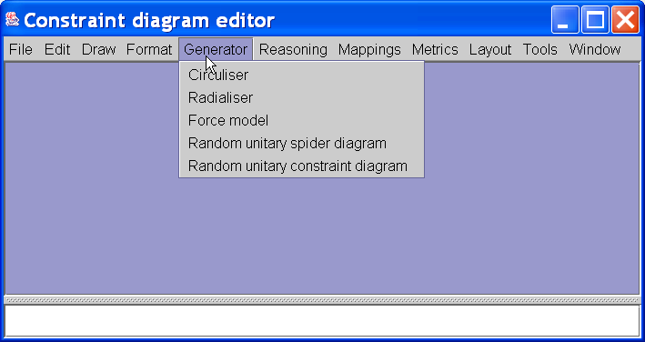

Circuliser: Uses Jean’s method to create an initial layout of an Euler diagram.
Radialiser:
Force model: Uses a force model to create an initial layout.
Random unitary spider diagram: Generates a random unitary spider diagram.
Random unitary constraint diagram: Generates a random unitary constraint diagram.

2.6 Reasoning menu

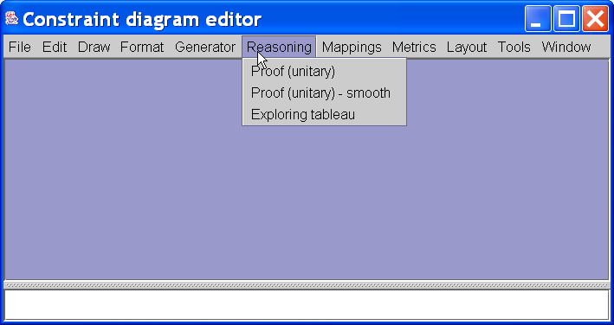

Prof(unitary): Implements reasoning rules for spider diagrams.
Prof(unitary) – smooth: Implements reasoning rules for smoothed spider diagrams.
Exploring tableau: Implements the tableau algorithm for spider diagrams.

2.7 Mappings menu

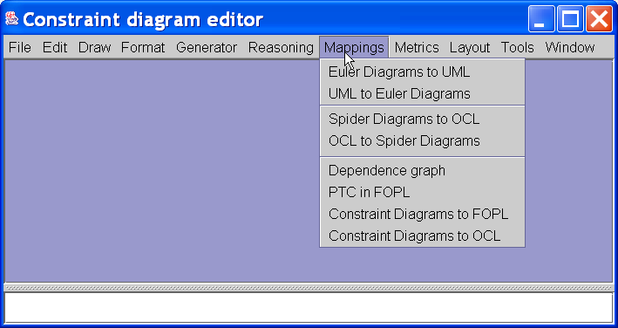

Maps spider and constraint diagrams to UML, OCL and FOPL. Computes the dependence graph for constraints diagrams.

2.8 Metrics menu

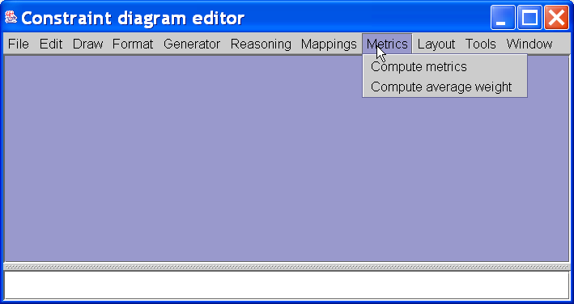
Compute metrics: Compute metrics on spider diagrams and stores the results into a file.
Compute average weight: Computes the average of metrics for spider diagrams using the content of the file in which the values were previously stored. These values can be used to set the coefficient for hill climber algorithms.

2.9 Layout menu

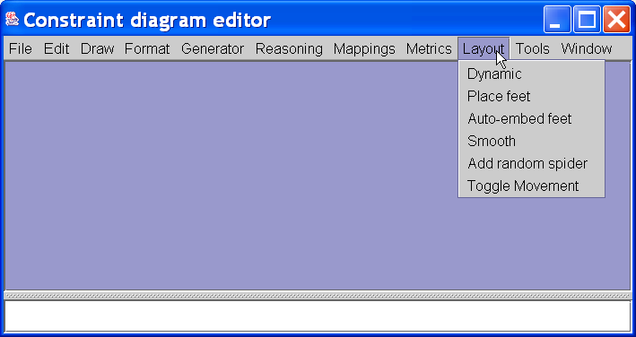

Dynamic:
Place feet:
Auto-embed feet:
Smooth:
Add random spider:
Toggle Movement:

2.11 Tools menu

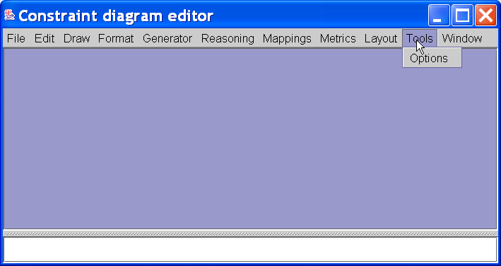

Options: Allows the selection of global options (e.g. default font, display concrete contours as ellipses and not as polygons)

2.11 Window menu

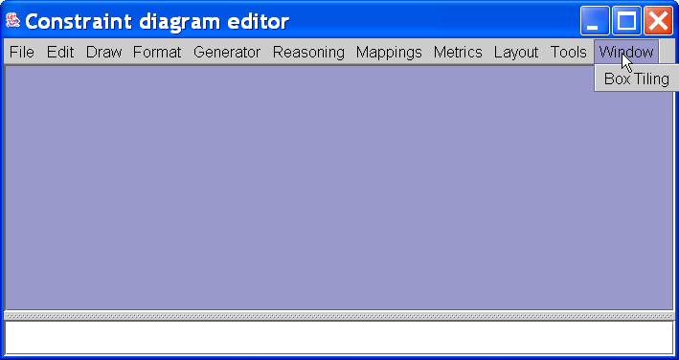
Box tiling: Tiles all windows so that they are of equal size and aspect ratio.

3 Miscellaneous

3.1 Toolbar

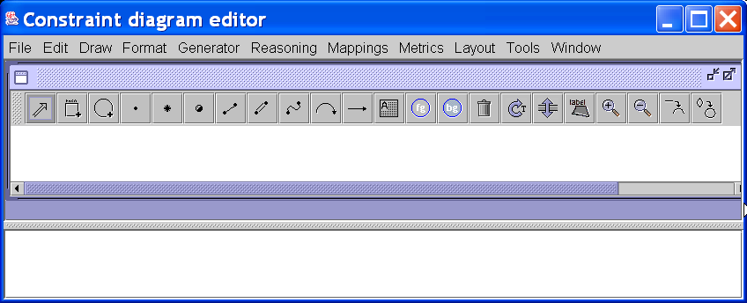

Contains shortcut for selection, edit and format functions that are available in the Edit, Draw and Format menus. The last two buttons display concrete contours using Bezier functions and ellipses.

3.2 Selecting

Diagram items can be selected by clicking on them. Contours, legs and feet must be clicked on. Zones are selected by clicking inside them. Multiple selection is supported using the Ctrl key.

3.2 Deselecting

Selected items are deselected by clicking on an area which the diagram does not cover.

3.3 Moving

Selected items can be moved by dragging the mouse. However, dragging directly over a control point will move only that control point. It is not possible to move a spider leg and connect it to other foot/feet. Instead the current leg must be deleted and then the new leg between the desired feet should be added.

3.4. Adding spider legs

Spider legs are added by holding down the shift key and dragging the mouse from one foot to another. A transparent dotted red line shows the leg that will be drawn if you
release the mouse button. The type of leg can also be changed (see later).

3.5 Changing types

The type of the selected item can be changed. This cycles between two types of feet and three types of leg (spider legs, strands, ties).

3.6 Resizing Items

A selected contour or box can be resized by selecting it first, then selecting and dragging a handle. When the mouse button is released, the new shape will
be drawn. Labels will move relative to the resizing. Resizing of shapes does not maintain their aspect ratio, thus it is possible to turn a circle into an oval.

3.7 Moving labels

Labels are moved relative to their parent diagram item. Labels can be moved independently by selecting an item and dragging the mouse while holding down the Ctrl key.

3.8 Moving reading trees

Reading trees attached to decoration boxes are moved relative to their parent diagram item. Labels can be moved independently by selecting an item and dragging the mouse while holding down the Shift key.

3.9 Popup menus

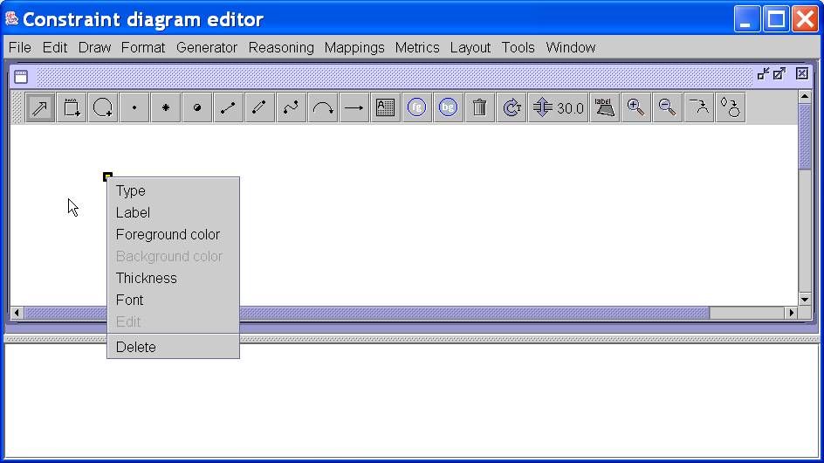

A context menu is available to support rapid change of attributes attached to a diagram items. Multiple selection is supported.

